Software Requirements Specification
for
DawAI
Version 1.0 approved
Prepared by:
102118001, Samyak Pandey (Offline)
102118009, Lakshya Gupta (Offline)
102118021, Shubhankar Sharma (Offline)
102118023, Abhinav Gupta (Offline)

BE Second Year, CSBS
Group No: Tinkers
Submitted to:

Computer Science and Engineering Department

TIET, Patiala

10 October 2022
Table of Contents
Table of Contents
1. Project Selection Base
1.1 Software Bid
1.2 Project Overview
1.3 References
2. Project Requirements
2.1 Functional Requirements
2.2 Non-Functional Requirements
3. Analysis Phase
3.1 Use-Case
3.1.1 Use-Case Case I
3.1.2 Use-Case Case I
3.2 Use-Case Diagrams
3.2.1 Use-Case Templates
3.3 Activity Diagram
3.4 Data Flow Diagrams (DFDs)
3.4.1 DFD Level 0
3.4.2 DFD Level 1
3.5 Data Dictionary
4. Design Phase
4.1 Class Diagram
4.2 Sequence Diagram
4.3 Collaboration Diagram
5. Implementation
5.1 Component Diagram
5.2 Screenshots
6. Testing
6.1 Test cases
6.1.1 Test Case 1
6.1.2 Test Case 2
6.1.3 Test Case 3(a)
6.1.4 Test Case 3(b)

Project Selection Base

Software Bid

Software Bid/ Project Teams

UCT 305- Software Engineering Lab

Group: BS-1 Dated: 09/08/2022
Team Name: Team Tinkers
Team ID (will be assigned by Instructor):

Name | Roll No | Project Experience | Programming Language used
ABHINAV  GUPTA | 102118023 | N/A | N/A
LAKSHYA  GUPTA | 102118009 | N/A | N/A
SAMYAK  PANDEY | 102118001 | N/A | C, C++, python, CSS, JavaScript, html5
SHUBHANKAR  SHARMA | 102118021 | Web Dev(front end), CNC writing machine, Bluetooth controlled car. | Html5, CSS3,  JavaScript,  Arduino IDE, C,  C++

Programming Language / Environment Experience

Project Name | Title with Description | USP* of the project
First Choice | DawAI : A site with an idea and motive to help people to get medicine with on based AI to help them instantly with their discomfort. It also suggests them yoga if they want to cure it in a long run. This AI will only support them for the disease which has some predictable symptoms but for the disease with complicated symptoms a doctor or a medical expert will get you into contact for the proper advice. This project will help you to get you proper advice for child care in their initial stages and suggests pediatricians. It helps you to get lab tests easily. | - Suggests medicine  with the help of AI.  - If the symptoms are complex then it helps you to get connected to the proper medical practitioner.  - Suggest pediatricians for child initial growth.  - Suggests yoga if want to cure disease in long term.  - Suggests proper lab test and help you to get them easily.
1.JavaScript
2.Python
3.Html/CSS

Choices of Projects:
Second Choice | AIreal eye: A flying drone which the capability to track a person’s movement in real time. It will help in solving the real-world example of replacing cameramen in events who sometimes would not able to capture the speaker properly or get a good shot. This drone has capability to controlled via remote or by itself (auto mode). A great idea to monetize as it fulfills the purpose of capturing the moment with full efficiency. | - Drone cameraman  - Surveillance  - Real Time  - Tracking  - Captures moment  with full efficiency
Third Choice | Booksack: A site with an idea which fulfills the purpose of college students to sell and buy their book in campus. Basically, it serves the purpose of buying and selling second hand books which reduces the effect to environment indirectly. This will be a type of ecommerce website for the secondhand books initially for the college students who want to buy books within the campus. This will work in large scale for the society after implementation of first stage. | ●  ●  ●  ● | Second hand books buying and selling Within campus buying selling initially then in large scale for others.  Reduces paper wastage  Meet the demand for the students.
Fourth Choice | DigitalDabba: A web development project with an idea and motive to help the people of the metro cities to deliver their tiffin through dabbawallas to their respective office with nearest checkpoints so that they reach on time. This kind of food delivery service project for the tiffin in metro cities.  This will help the dabbawallas to connect digitally with the public in this digitalized world. | ●  ● | Helps you to get shortest path with checkpoints to collect more tiffin.  Time management.

Additional Remarks/ Inputs

We want to work on the project “DawAI” as it will help the society to get medicine (small symptoms or common symptoms) instantly which will not only help the people to get less charged for meeting with the doctor but also the workload of the doctor will get reduced to repeat the medicine. This project was also our choice as it will become completely monetized and quite profitable if worked in future and might will become a startup or a unicorn for our country.

1.2 Project Overview

The purpose of this document is to provide a correct and complete description of the requirements for the software of DawAI. The requirements will be shown in a written description to explain various concepts and different types of functionalities with relevant information.

Main features of our website portal DawAI are:
- DawAI focuses on providing advice to the client to find their medicine in emergency cases on the basis of their symptoms (predictable) and help them to connect to the medical practitioner.
- DawAI advises the client about the yoga practices which they can perform to cure the uneasiness in the long run. DawAI also focuses on providing childcare advice for their initial development and helping clients to suggest and connect to pediatricians.
- DawAI also helps you to get lab tests in easy steps.

Every day many people suffer with many of the health problems or for better healthcare. The software of DawAI is responsible in making the people to take better healthcare decisions and health related issues. This will help the client in finding the better suggestions regarding health from the best doctors and also help the client to somewhat cure or reduce the uneasiness caused by the illness by suggesting them medicine based on their symptoms.
By this software DawAI, people start finding the help from the best doctors which can be managed by single health care account for the entire family. It also secures all the sensitive information regarding the healthcare data so as to make better healthcare decisions from past reports also. This software is looking to simplify healthcare access and help you to make healthcare decisions. With search, we help you to find and decide on the right healthcare providers across doctors, hospitals and diagnostics and provide easy steps lab tests. Every day billions of people struggle for better healthcare. We are on a mission to help mankind to live healthier and longer. This software also has scope in childcare facility which they all seek in their initial stages.

References

- Net meds –

https://www.netmeds.com/healthstore?source_attribution=ADW-CPC-Search-PY-Generic&utm_source=ADW-CPC-Search-PY-Generic&utm_medium=CPC&utm_campaign=ADW-CPC-Search-PY-Generic&gclid=Cj0KCQiAgribBhDkARIsAASA5buOSsHAbTUu2M3Fc4FsgP0QThlLfz7nzrFvo5R9aPmz5vfrHTv53ScaAp0LEALw_wcB

- Apollo Pharmacy –

https://www.apollopharmacy.in/?utm_source=google&utm_medium=srnb&campaignid=13448533801&adgroupid=127019844167&keyword=medicine%20websites&device=c&adtype=&product_id=&utm_campaign=Apollo_Pharmacy_Non-Brand_RestCities_New&utm_content=Medicine%20Online%20EM&gclid=Cj0KCQiAgribBhDkARIsAASA5bsPNBAzdpvkEIwhF-btLuJKjFqrChXSZSJjKLVQO-haBuw6GDdTN54aAqTSEALw_wcB

- Pharmeasy –

https://pharmeasy.in/

- Truemeds –

https://www.truemeds.in/

- Baby Care Advice -

https://www.babycareadvice.com/blogs/baby-care/swaddling-baby

Project Requirements

Functional Requirements

- On the login screen, after the user types in their username and password and click submit, the user’s credentials are validated and if correct they are logged in, otherwise an error message is displayed.

- In the sign-up screen when a new user types in all of their information and clicks submit, the data is then validated. If there is an existing user then the user is asked to enter a new username. If there is no conflict then the user is registered.

- When the user selects a category and clicks on find button, the interface should redirect to a new page that displays the results.

- If the user selects any filter on search results page, only the search results that match the filter constraints, should be displayed.

- If the user clicks on details button on a result, the interface shows the detailed profile for that account on a new page.

- Booking details should be mailed to both the client and the Doctor

- The unique id created should match exactly with mobile number.

Non-Functional Requirements

- It must not contain duplicate accounts of the same doctor/laboratory.

- The contact details provided by a user should be valid.

- The contact details of each doctor should be easily accessible.

- There should be security of personal information provided by a doctor.

- The available information should be reliable.

- The system should be easy to use by any computer-literate person.

- The payment Gateway should be available 24x7

- The web portal should be accessible on any device (device friendly).

Analysis Phase

Use-case

Use-case I:

- (SR)The Portal asks for symptoms.

- (AA) The user enters the symptoms.

- (SR) The Portal searches the database for related symptoms and gives the recommendation of medicine accordingly.

- (SR)The portal asks if doctor consultation is required?

- (AA)user enters “yes”

- (SR)The portal redirects to doctors and specialists’ page.

- (AA)User selects the doctor for consultation and the time slot accordingly.

- (SR)Portal Redirects to the payment gateway where the required fees for appointment can be submitted and then shows a confirmation message.

- (SR)The portal also sends a confirmation email to the doctor and client and updates the database.

Use-case II:

As A user (Member)
I WANT TO have login facility
SO THAT I can access the website and its contents

+SCOPE+
Member registration
Member Validation

Member should be able to change the password
It should work in all browsers
It should be device friendly

PRE CONDITION
User should have a credit/debit card
User should have booked and consulted the doctor earlier

+Acceptance Criteria+

SCENARIO: User can successfully login
Given I am on login page
And fill the login details
Then database is checked
And logged in if found entry
And Displayed Error if Entry not found

SCENARIO: Registration
Given I am on login page
And I click on “new user?”
Then I get redirected to registration page
And I fill in all the details
Then my details get verified and entry is made to Database
Scenario: Buy Membership
Given I am on home page /dashboard
And I click on buy membership button
Then I am shown all the different prices and plans
And I select the suitable plan
Then I am redirected to payment portal
And displayed message Welcome Aboard in case of successful payment
Then I can also check my membership status from profile.

Use-case III:

As a user (Member)
I WANT TO have a doctor contact facility
SO THAT I can personally contact the doctor in case of emergency

+SCOPE+
Build a doctor contact database
Member Validation
Only consulted doctor contact should be shared
It should work in all browsers
It should be device friendly

PRE-CONDITION
User should be a member of DAWAI
User should have booked and consulted the doctor earlier.

Use-case Diagram

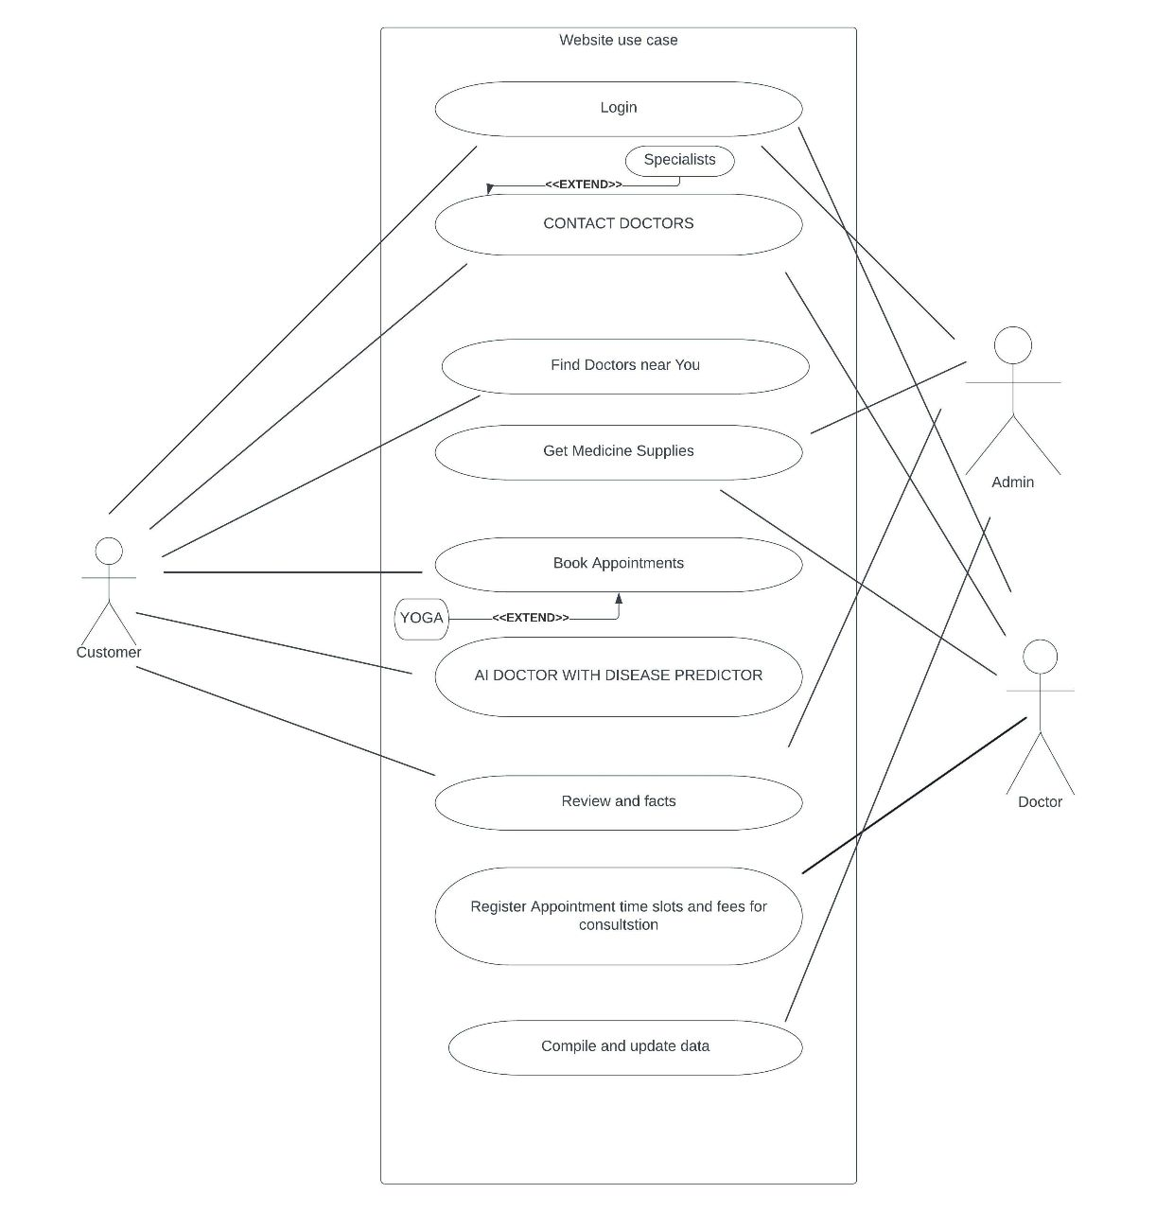

Use-case Template

NAME | DAWAI WEB APP (Login and booking)
ID | 10211-DAW-09
DESCRIPTION | CONNECTS DOCTORS AND PATIENTS ALONG WITH SUGGESTING THEM MEDS AND LAB TESTS
ACTORS | MEMBERS, DOCTOR, ADMIN
ORGANISATIONAL BENEFITS | ANNUAL MEMBERSHIP CHARGES
PRE-CONDITIONS | USER SHOULD HAVE A GOOD INTERNET CONNECTION FREE FROM VPNS AND PROXY’S  USER SHOULD BE A REGISTERED MEMBER OF DAWAI LTD.  USER SHOULD HAVE READ THE TERMS AND CONDITIONS PROPERLY
POST CONDITIONS | THE USERNAME AND PASSWORD SHOULD NOT BE SHARED  UNIQUE ID SHOULD NOT BE SHARED PUBLICALLY  PATIENT DATA SHOULD NOT BE PROVIDED TO ANY THIRD-PARTY APPS
MAIN COURSE | 1.LOGIN AND MEMBERSHIP FACILITY  2.CONNECT DOCTORS AND PATIENTS  3.SUGGEST LAB TESTS, SPECIALIST DOCTORS, MEDICINES  4.HELP IN BOOKING APPOINTMENTS WITH DOCTORS  5.PROVIDE YOGA AND FITNESS FACILITY  6.HELP CENTRE  7.CONTACT DOCTORS DIERECTLY
TASK SEQUENCE | - USER ENTERS USERNAME AND PASSWORD  - SYSTEM VALIDATES USERNAME AND PASSWORD, ALLOWS ENTRY IF MATCH, SHOWS ERROR IF NOT MATCHED  - SYSTEM REDIRECTS TO THE HOME PAGE  - USER CAN CHOOSE DOCTOR FOR APPOINTMENTS AND CAN ALSO BOOK LAB TESTS AND MEDICINES
FREQUENCY | ONCE
CONSTRAINTS | REQUIRES DOCTOR ACTIVE PARTICIPATION, MEDICINES SUGGESTED CAN’T BE ORDERED WITHOUT CONFIRMATION BY DOCTOR
SPECIAL REQUIREMENTS | MEMBERSHIP PLANS PAYMENT GATEWAY

Activity Diagram

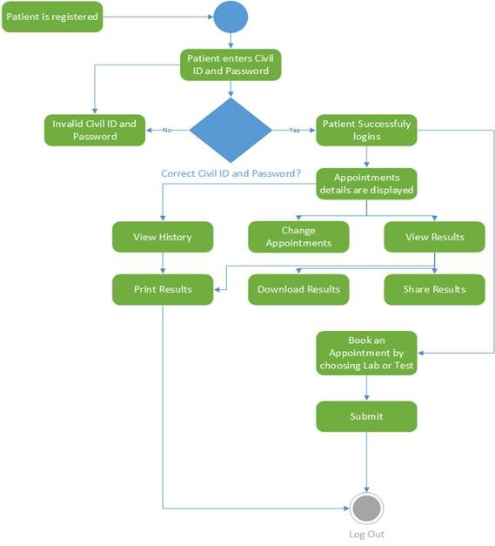

Data Flow Diagrams

DFD Level 0

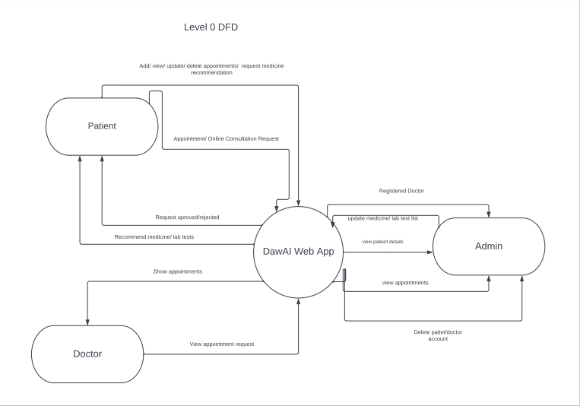

DFD Level 1

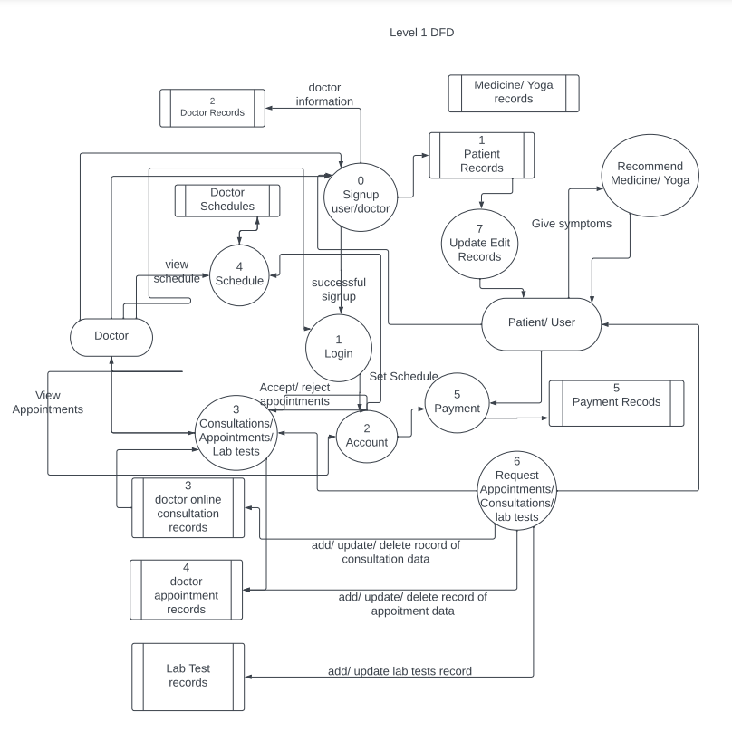

Data Dictionary

Field Name | Field size | Data Type | Data Format | Description | Required?
First Name | 30 | char | - | First name of the User | Yes
Last Name | 30 | Char | - | Last name of the user | yes
Age | 3 | int | - | Age of user | yes
Earlier disease | 30 | char | Disease1, disease2... | Disease diagnosed earlier | No
Mobile number | 10 | int | - | Phone number | yes
Address | 90 | char | - | Address of user | Yes
Membership status | 1 | Boolean | - | Displays Member or not | No
Personal Id no. | 10 | int | mobile | Unique number of Member | Yes
Gender | 5 | char | First5letters | Gender of User | Yes
Aadhar card number | 16 | Str | Abcd-1234-efgh-5678 | Aadhaar no. of user | No
Doctor Status | 1 | Boolean | - | Displays user a doctor or not | Yes
Doctor contact | 60 | str | Mobile-email-address | Contact of doctor | No
Disease | 10 | str | - | Disease | No
Symptom | 10 | Char | - | Symptom of user | No

Design Phase

Class Diagram

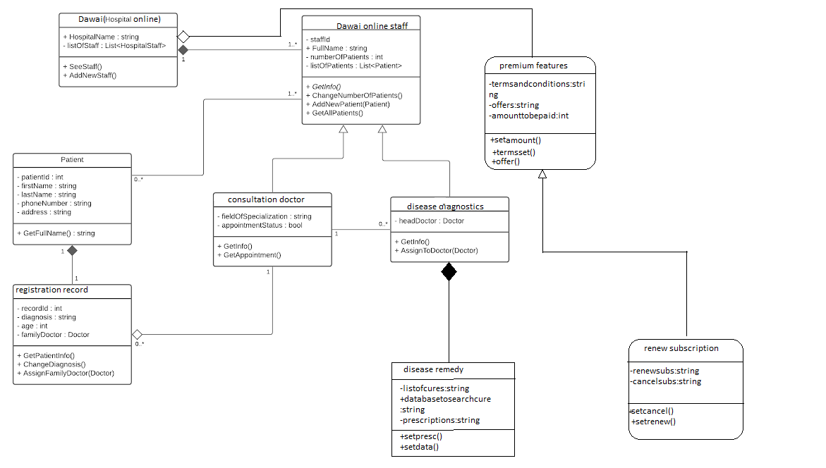

Sequence Diagram

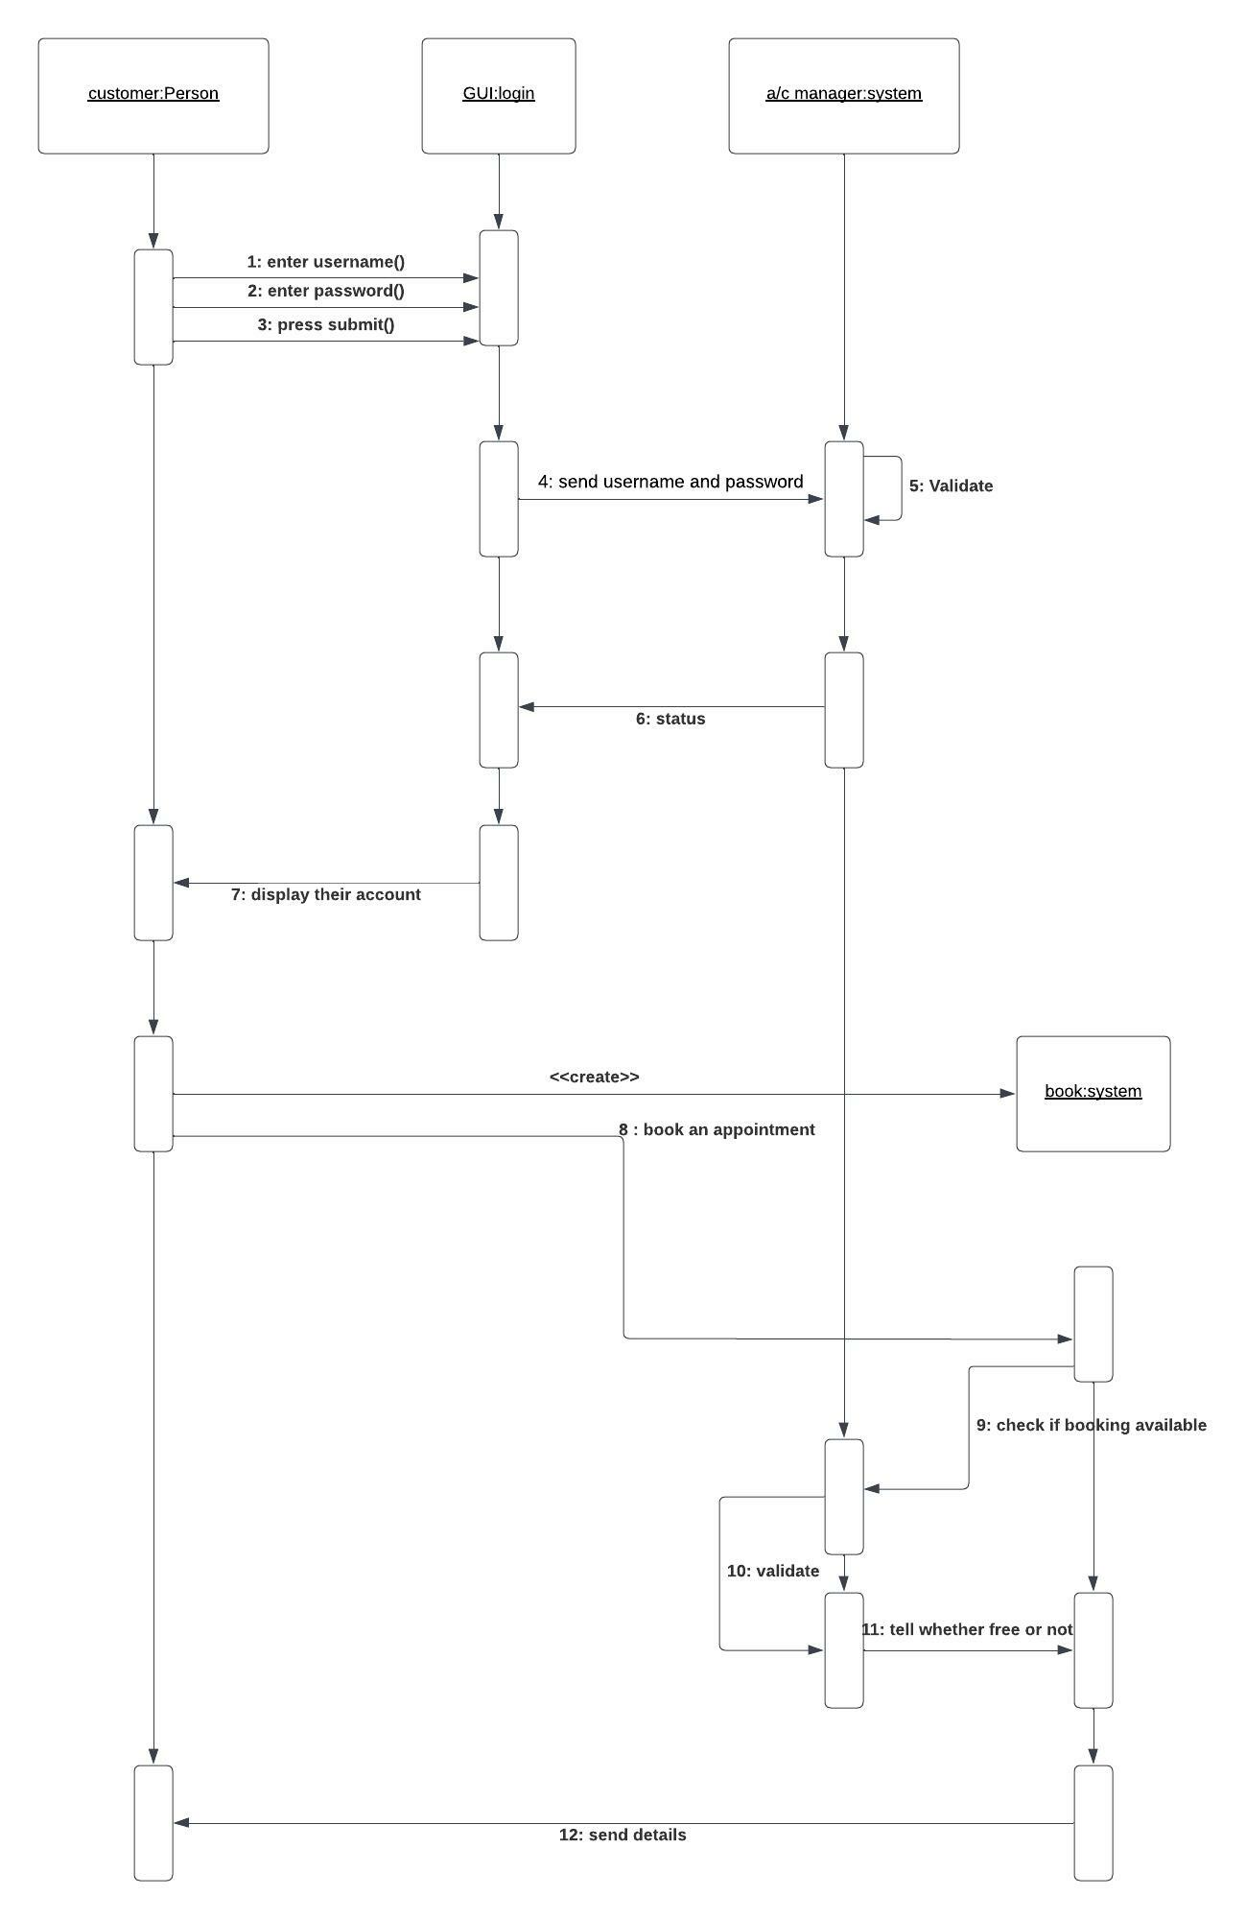

Collaboration Diagram

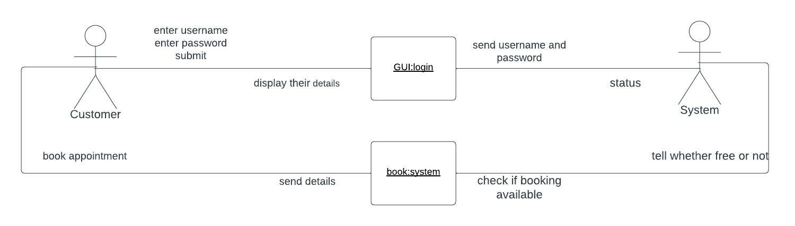

Implementation

Component Diagram

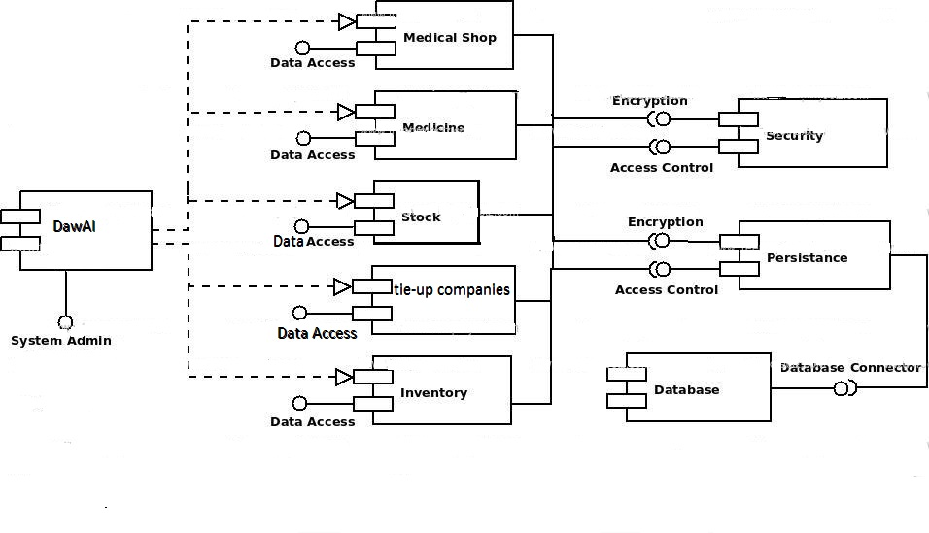

Screenshots

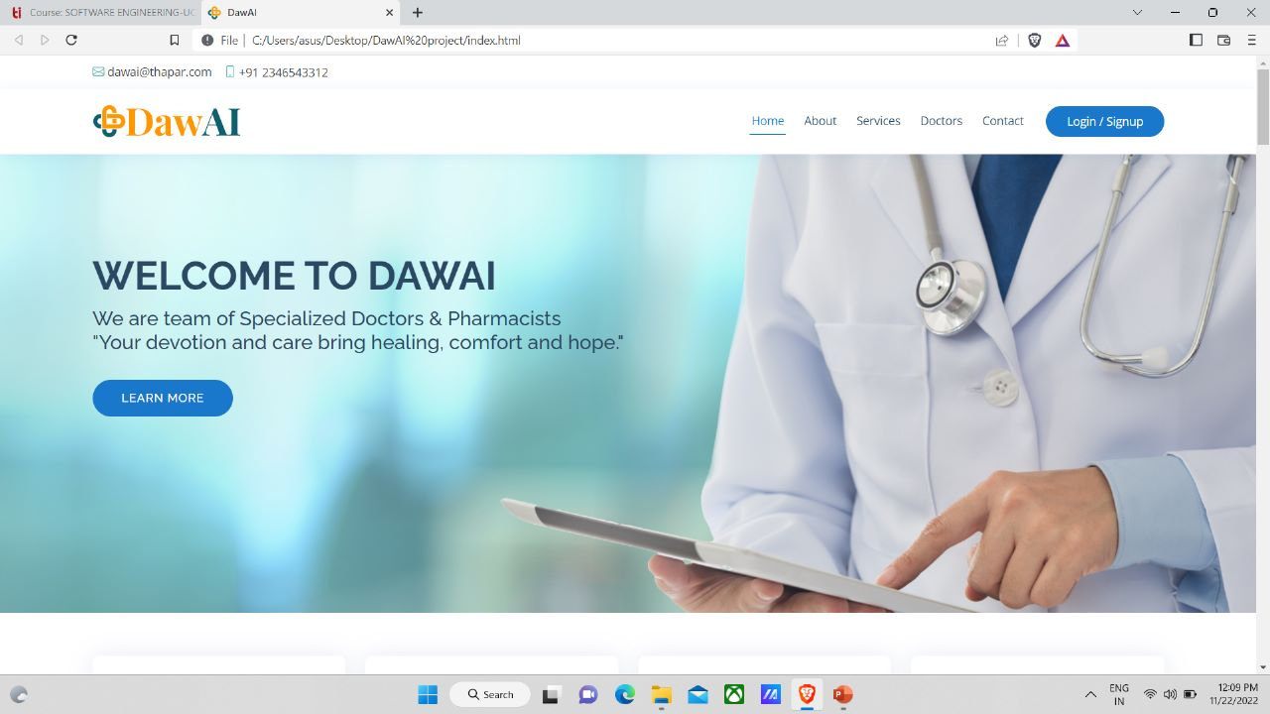

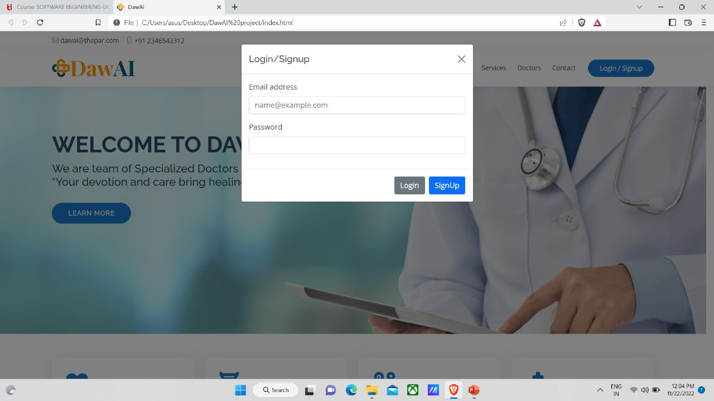

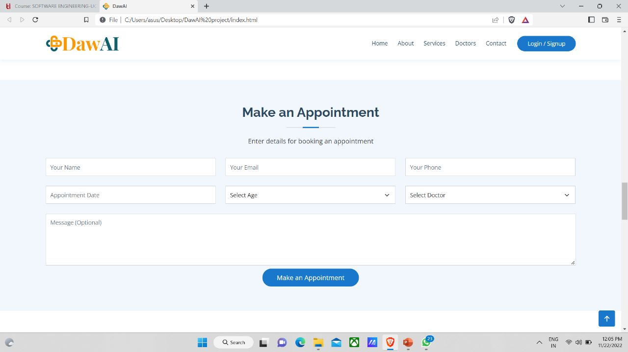

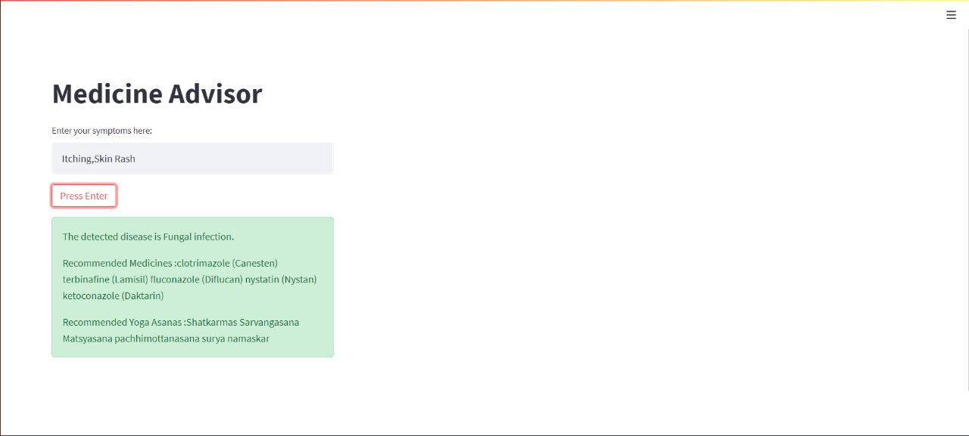

Testing

Test Cases

Test Case I:

Test Case:1.1
System: DawAI Designed By: Tinkers
Executed By:
Test Case Name: Doctor Appointment Subsystem: Appointment Schedular Design Date: 1/10/2022
Execution Date:
Short Description: Testing of getting an appointment.

Pre-Conditions:
- Patient must be logged in and registered.

Step | Action | Expected System Response | Pass/Fail | Comments
1. | Book appointment | System displays a search bar along  with a list of categories such as ENT, dentist etc. | pass
2. | Selection of a category | System displays list of doctors  available for the category and the recommended doctor which the site has recommended according to patient symptoms | pass
3. | Selects of a doctor | System sends patient details to respective clinic. | pass
4. | Clinic approves patient request. | Patient receives confirmation from system along with necessary details.  Such as contact information, address etc. Patient redirected to home page. | pass
Post-Conditions:

- Patient redirected to home page.

Step | Action | Expected System Response | Pass/Fail | Comment
1 | Navigate on login Button | Able to see login page | pass
2 | Enter username | The username entered in  username field | pass
3 | Enter password | The password entered in  password field | pass
4 | Click login button | The user is logged into system  and form will be displayed | pass
5 | Enter invalid password | The message “invalid username  or invalid password” is shown

Test Case II:
Test case #:2.1
Test Case Name: login into system
System: DawAI
Subsystem:
Designed By: Tinkers
Design Date:1/10/2022
Executed By: Tinkers
Execution Date: 1/10/2022
Short Description: Testing the login functionality in system
Pre-conditions:
The user has a valid user account and password The system displays main page

Post condition:
User is validated with Database and successfully log in to account. The details of user will be displayed if it is available.

Test Case III(a):
Test case #:3.1
Test Case Name: Signup into system
System: DawAI
Subsystem:
Designed By: Tinkers
Design Date:1/10/2022
Executed By: Tinkers
Execution Date: 1/10/2022
Short Description: Testing the Signup functionality in system
Pre-conditions:
The user has a unique UID and valid phone number or email ID
The system displays main page

Step | Action | Expected System Response | Pass/Fail | Comment
1 | Navigate on Signup Button | Able to see login page | pass
2 | Enter username | The username entered in username field | pass
3 | Enter password | The password entered in  password field | pass
4 | Enter password again | The password entered into  confirm password field | pass
5 | Enter age | The age entered in  age field | pass
6 | Enter phone no. | The mobile no. entered into  contact field | pass
7 | Click signup button | The message will come to your phone that you have registered  yourself successfully | pass

Post condition:
The record of user is stored in database after successful signup.

Test Case III(b):
Test case #:3.2
Test Case Name: Signup into system
System: DawAI
Subsystem:
Designed By: Tinkers
Design Date:5/10/2022
Executed By: Tinkers
Execution Date: 5/10/2022
Short Description: Testing of alternate flow of events on Signup functionality into system
Pre-conditions:
The user has a Gmail ID.
The system displays main page

Step | Action | Expected System Response | Pass/Fail | Comment
1 | Navigate on Signup with Gmail Button | Pop-ups to new window where it asks user to give access and permission of its Gmail account to DawAI | pass
2 | Navigate to allow access | The user after reading the terms and condition clicks on the allow access button | pass
3 | Click signup button | The message will come to your Gmail that you have registered yourself successfully | pass

Post condition:
The record of user is stored in database after successful signup.

